Use cursor keys to move between fields  Please complete all fields. Failure to do so may result in delay. No returns will be accepted without prior approval via this Authorisation Form.  Email completed form to:  ft.orders@fttechnologies.com |  | Your RMA has been authorised  Please follow the instructions below:
Customer Contact Information |  | PRODUCT RETURN INSTRUCTIONS | PRODUCT RETURN ADDRESS
Company Name |  | 1) Write RMA no. on returned package | FT Technologies (Intl) Ltd
Department |  |  | Goods Receiving
Address Line 1 | Haiqing Industrial Park,  Economic & Tech Development Zone,  116600, Dalian, China | 2) Print this form and insert into package | Sunbury House, Brooklands Close
Address Line 2 |  |  | Sunbury-on-Thames
Address Line 3 |  | 3) Make sure goods are adequately packaged | TW16 7DX
Postcode / Zip code |  |  | United Kingdom
Country |  | 4) Send packaged goods to 'Product Return Address'
RMA Request Date |  |  | Attention: Production Manager
Contact Name
E-mail Address
Contact no.

Please note: If the sensor(s) are not returned within 12 weeks of the date of issue the RMA will be cancelled. A new application to return the sensor may be made but the warranty status will be calculated from the date of this new application.

Product Returns Information |  |  |  |  | FT USE ONLY
Serial No. | Engraved Body No. | Product Part No. | Fault Description | Customer Reference | RMA No. | Job No.
Format: XXXX-XXX | Format: XXXXX |  | Please Provide Full Description of Fault | Optional

When returning sensors to FT it is important that suitable packaging is used to provide adequate protection to the sensor. If the sensors are damaged during their return it may invalidate the warranty and make it harder to properly diagnose and repair the fault.

The wind sensor measurement cavity must not have tools or sharp objects inserted in to it and cable ties must not be attached to the pillars.
Sensors should be packaged in such a way that they cannot be easily damaged during transport. Some examples are shown below

Good Packaging Examples | 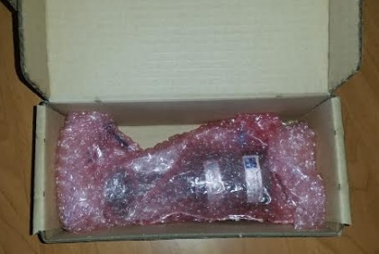
Bad Packaging Examples:  - Poor quality packing  - Cable tie fitted around the cavity pillar  - Label has been applied to the cavity | 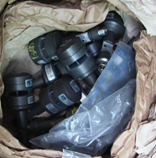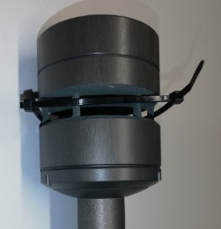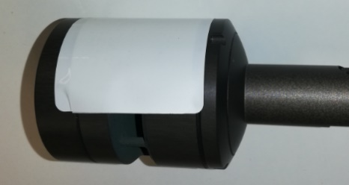

Sensors should be packed as follows:
- Use the original FT packaging. If this is not available use a suitable double-layered cardboard box
- Protect each sensor with 2 layers of bubble-wrap
- Use additional padding to secure the sensors in position within the packaging (the sensors should not be capable of significant movement within the box)
- Service and RMA documents should be placed on top of the sensors (or with the shipping documents attached to the outside of the package)
- Do not attach anything around or inside the sensor cavity (for example: labels and zip ties)

Failure to comply with these guidelines may result in damage to the sensor and invalidate the warranty.

For more information please contact our team: +44 (0) 20 8943 0801 or ft.orders@fttechnologies.com

